STW104KM Enterprise Information Systems

**Assignment-II**

Attempt all questions.

**Section A**

1. ***Itahari Arts*** scenario below.

**Background and requirements**

Itahari Arts is an arts company that handles and Organize plays and musicals at a range of venues across the country. Loyalty scheme are provided for customers as they receive a discount on future bookings. Current discount levels are 5% for bronze customers, 7% for silver and 10% for gold customers (see figure 1).

The customer will phone ***Itahari Arts*** and the receptionist will book the tickets. Each booking can have many tickets. The booking form will include the customer details (see figure 2), the quantity of tickets, the event name and other details such as the venue and price (see figure 3). Payment can be made either In cash on delivery(COD) or by Online payments services like E-sewa , IME pay , Khalti. After the booking has been made the customer will receive email confirmation and tickets (figure 4) are either collected at the venue or sent in the post.

Suppose you are hired as IT Consultant for Itahari Arts. Itahari Arts would like an online booking system and one can also provide management information relating to bookings for business planning purposes.

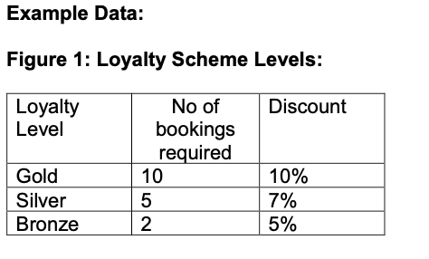

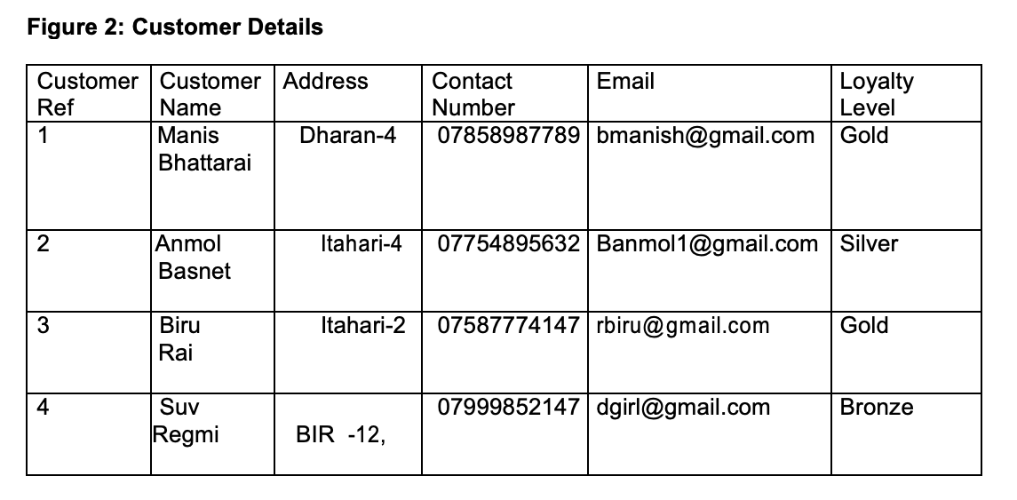

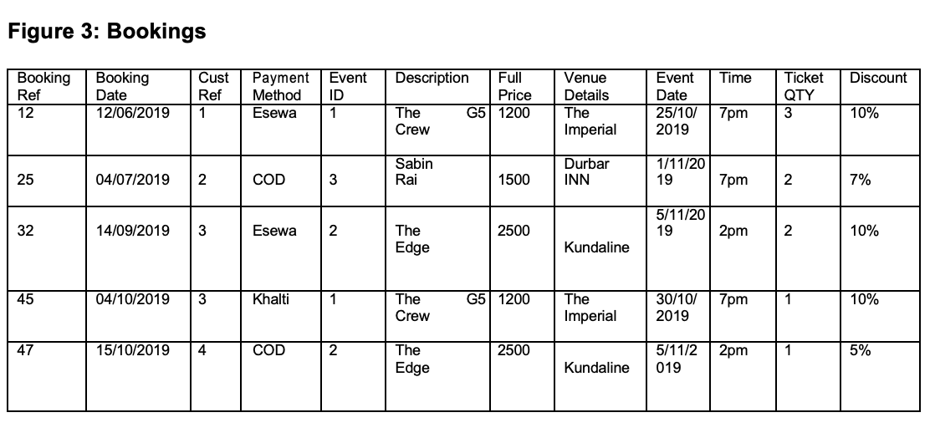

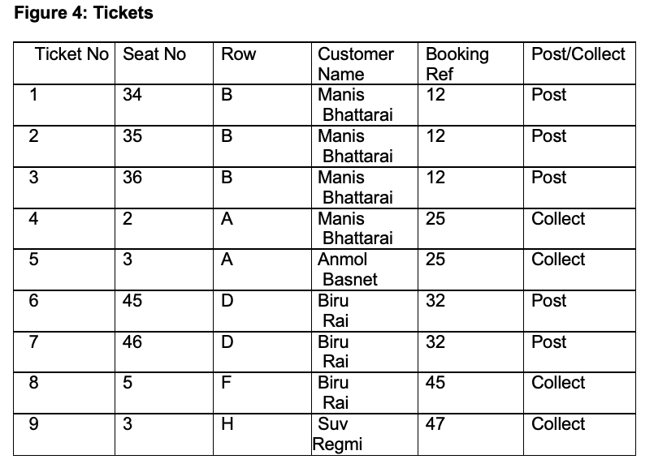

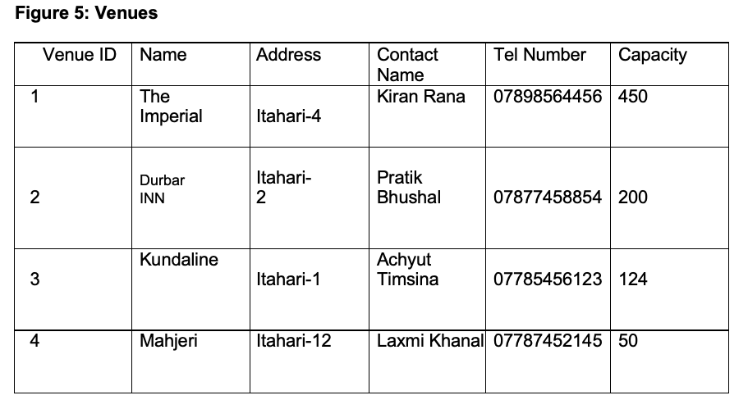

**NOTE: Provided data are not Normalized Data and it is Candidate’s Task to Normalized the data in most Optimal way. Remove Redundancy and all anomalies in above data that could be Insert, Delete and Update anomalies.**

**Task**

1. Produce an entity relationship model for the proposed system for ***Itahari Arts***. This should be a fully normalised model to 3rd normal form [13]
2. Create all the normalized tables in SQL. Show your SQL scripts and the finished tables. [10]
3. Enter all data on Normalized Table and show Result [5]
4. Write a query that selects the first name and surname of customers in alphabetical order of surname [2]
5. Write a query that shows the number of all the bookings according to their Payment Methods [4]
6. Change the contact name for ‘The Imperial’ to Sudeep Shrestha [2]
7. Delete the venue ‘Mahjeri’ [2]

**Section B**

Suppose you are hired as IT Consultant for Itahari Arts.

1. How would you suggest Itahari Arts to implement various Cloud Computing services to improve on their existing business operations? [6]
2. Suggest one appropriate software development model for developing the online booking system for Itahari Arts. Briefly Describe phases in chosen Software Development model and list out the Pros and Cons of the model [6]